

**Name-Pratiksha Shinde**

**Basic Linux Commands Assignments**

**Assignment-1**

Connect and disconnect with login Access

* What happens when you login a non-existent users or username?
  + 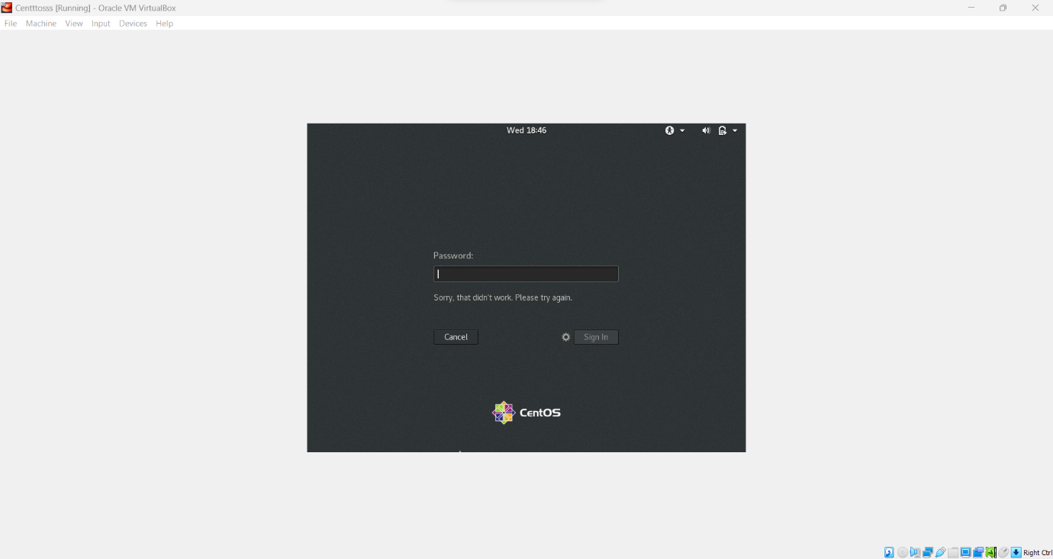Provide Screenshot and What you understand, explain in short brief?
* **Observation**-Unable to sign in with non-existing user. It will throw error message as Sorry,that didn’t work.Please try again.

**Assignment-2**

Password changing

* Login into your account and then change password?
  + Change your password into **IneuR0n#42** and hit the **Enter** key
    - Explain what happen and give screenshot?

**Observation**: To change the password first it will ask for current password then add New password and verify. After verification new password will set successfully.

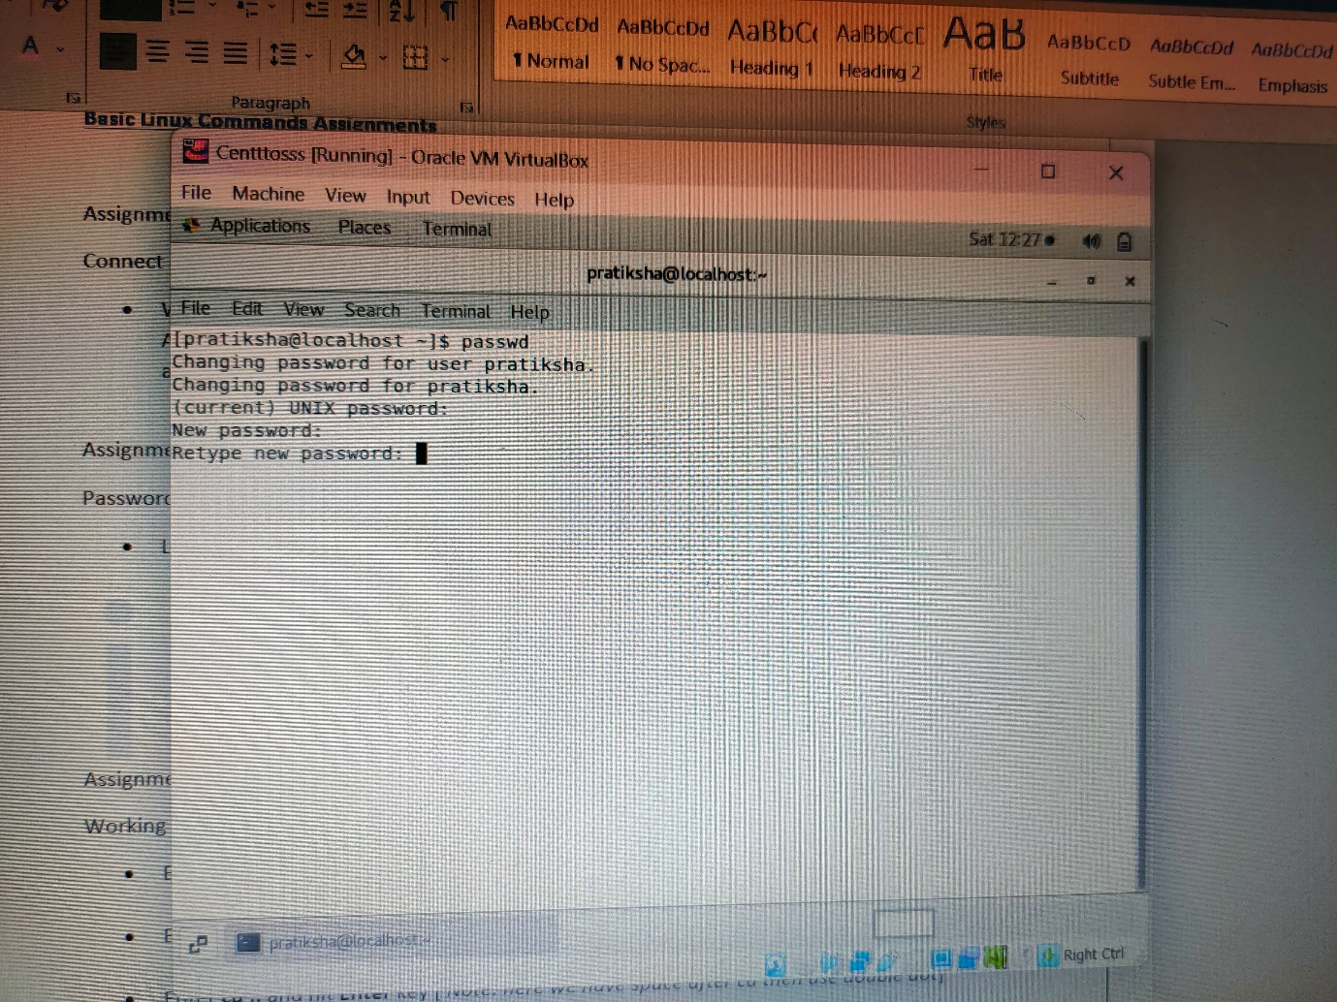

* + Try again to change password but use like password ***1234*** or ***abcd***
    - 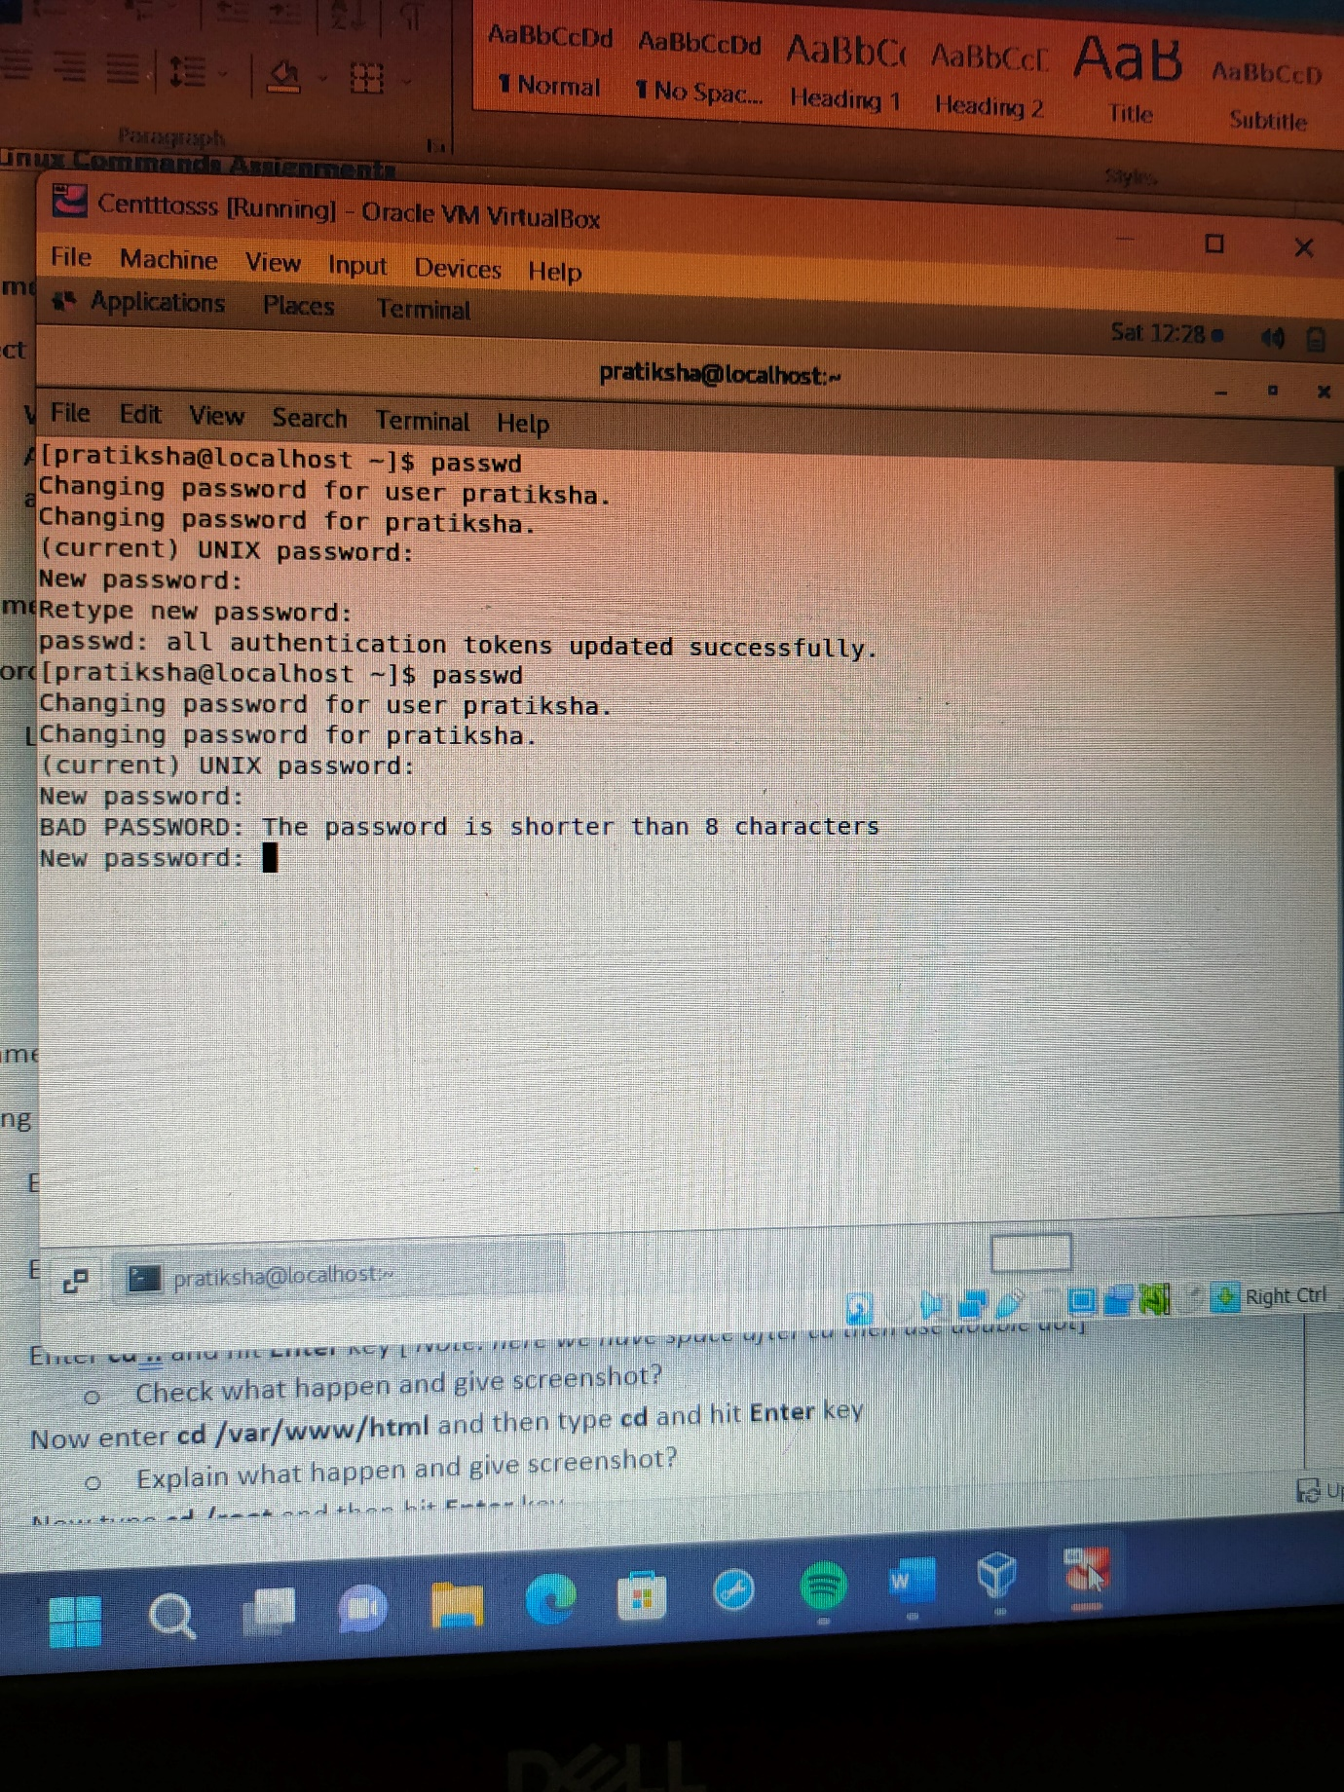Explain what happen and give screenshot?
    - **Observation:** It will display password is shorter than 8 characters that is Bad password and will ask for new password
  + Try again to change password but now don’t use any password just hit **Enter** key
    - Explain what happen and give screenshot?
* 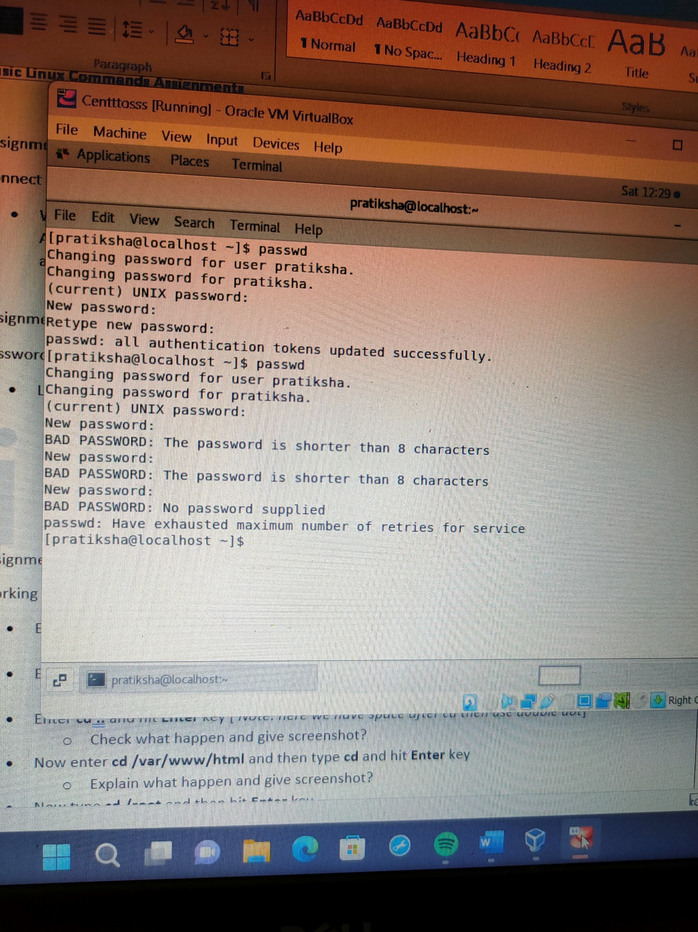**Observation**: As password is not provided it will show no password supplied.

**Assignment-3**

Working with Directories

* Enter the command **cd /** and then **ls** and then hit **Enter** key
  + 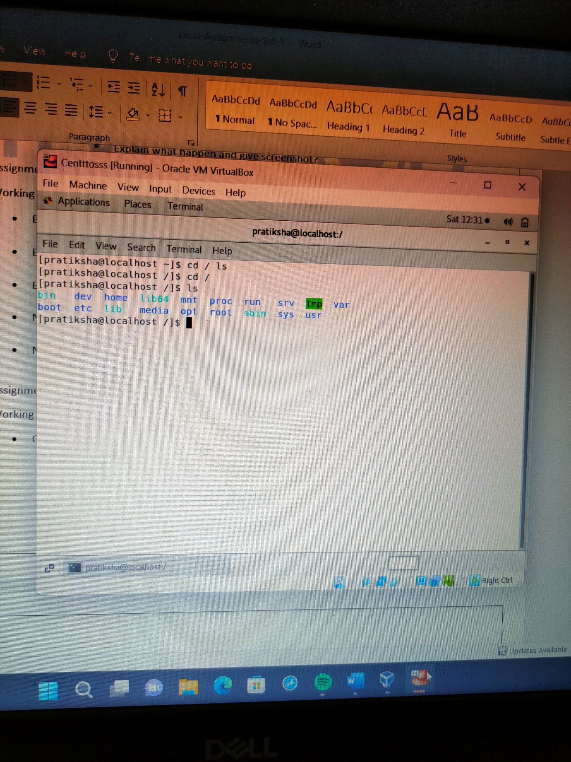Take screenshot and explain what output we got?

**Observation**: It will show all the files/ directories listed in main folder/directory

* Enter the command now **cd /home** and then hit **Enter** key
  + 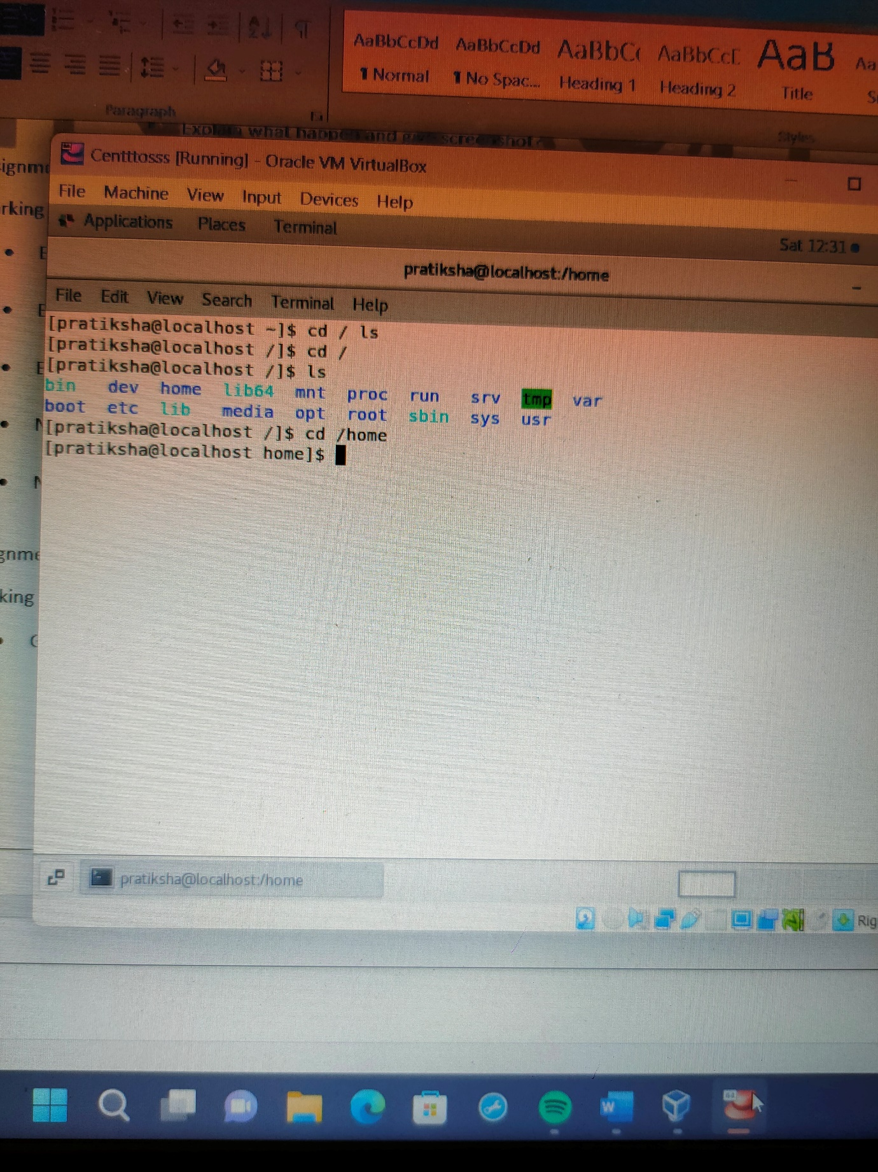Do **ls,** provide screenshot and explain what is **/home** directory used for?

**Observation**: Directory changes to home directory and after adding command ls it will show all lists present in home directory.

* Enter **cd ..** and hit **Enter** key [ *Note: here we have space after cd then use double dot*]
  + 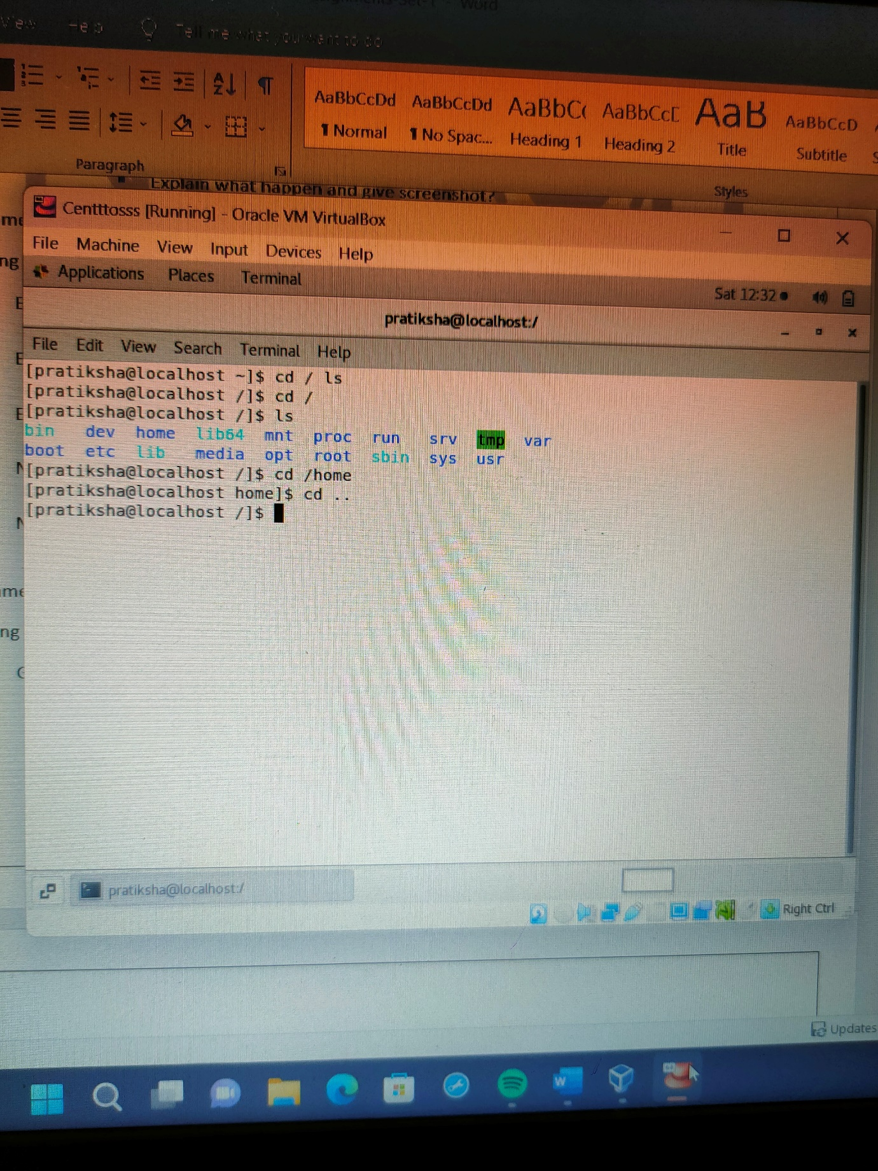Check what happen and give screenshot?

**Observation** : Directory changes from home to host/main directory.

* Now enter **cd /var/www/html** and then type **cd** and hit **Enter** key
  + Explain what happen and give screenshot?

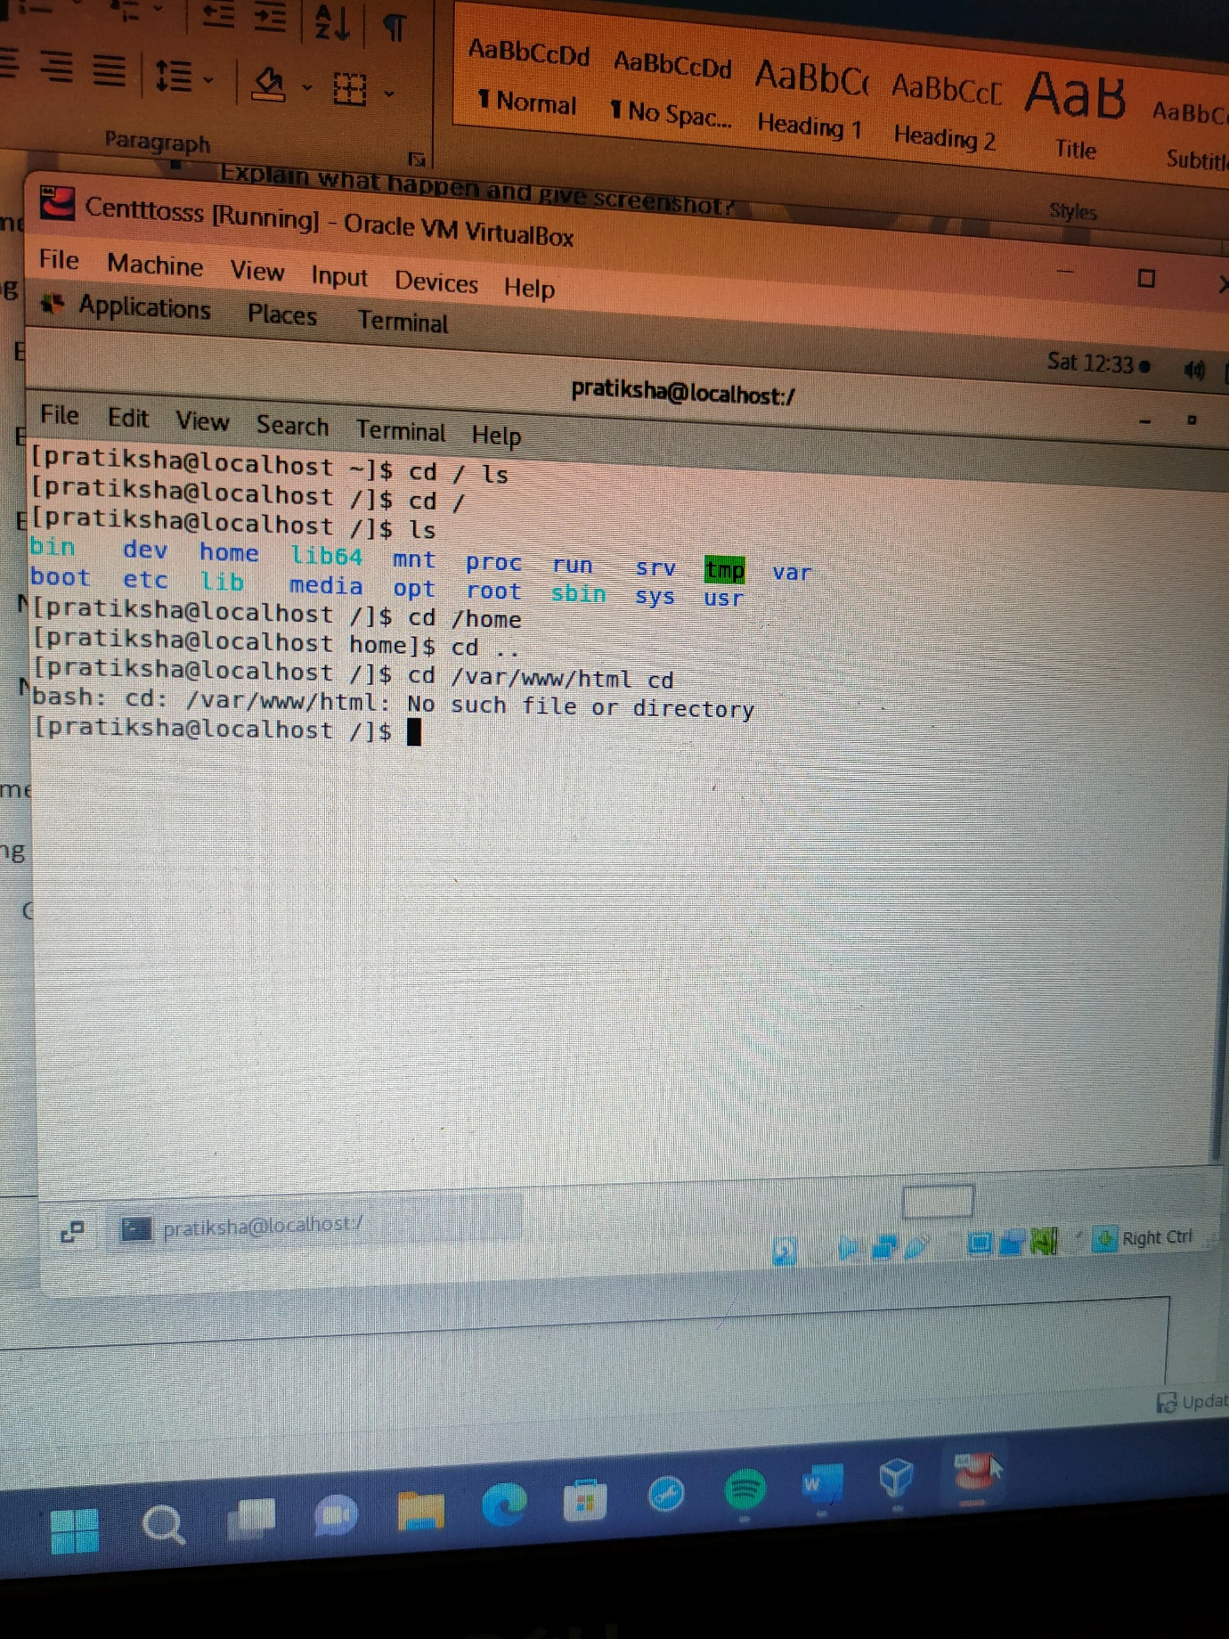

* **Observation**-No such directory or file will be shown as output
* Now type **cd /root** and then hit **Enter** key
  + 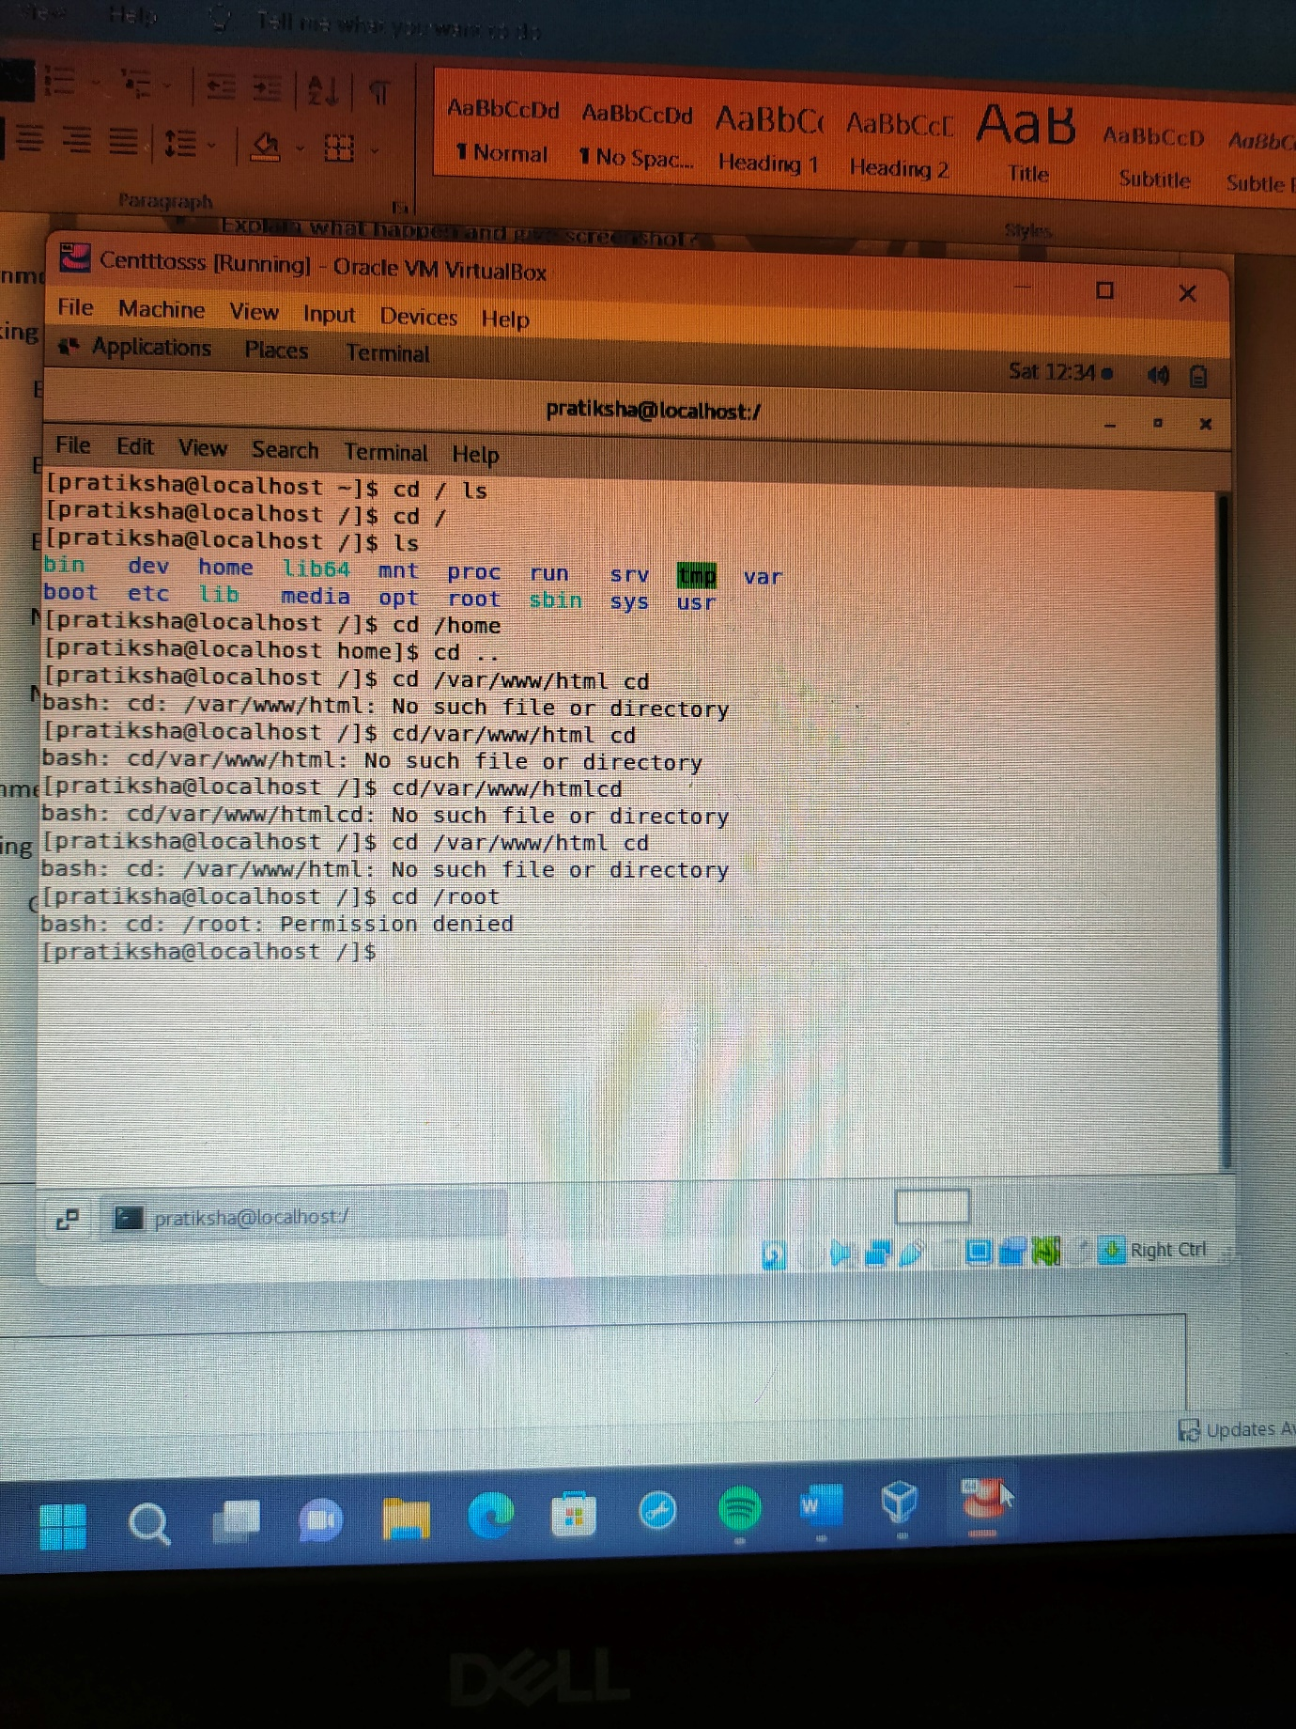Do **ls,** check any output we have on screen if yes then take screenshot?

**Observation**: There is no permission to change directory into root

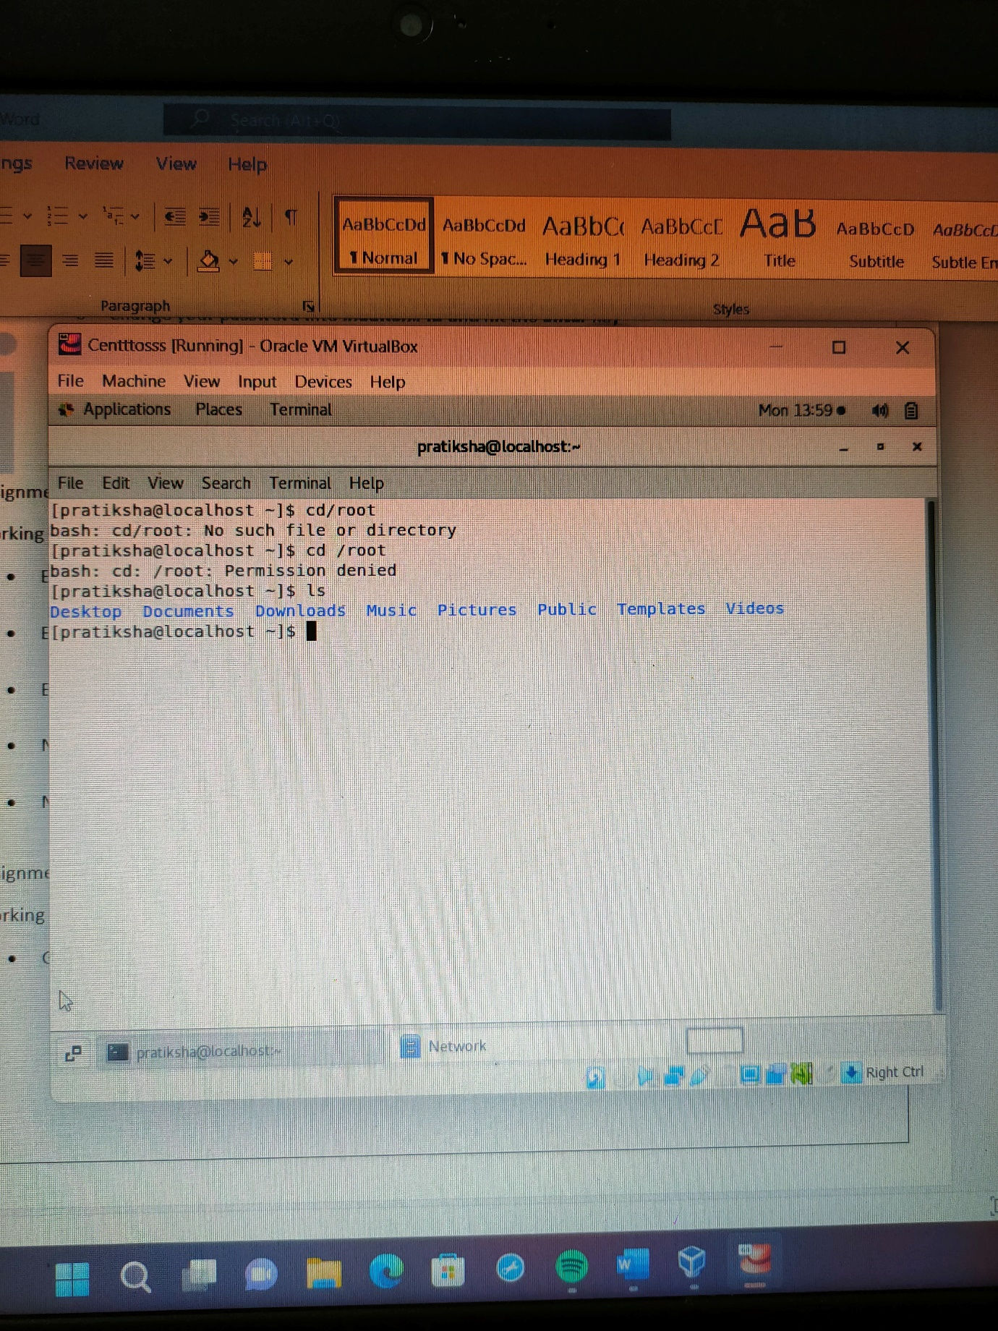

**Observation**: There is no permission to change directory into root directory. After adding ls command it will display all folders present in the home folder.

**Assignment-4**

Working with File Listing

* Go to **cd /etc** and type **ls**
  + Take screenshot and explain what files you have seeing?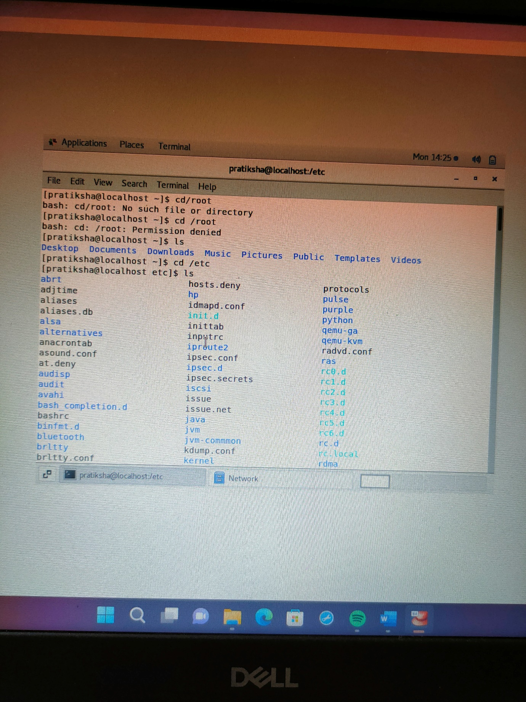 Take screenshot and explain what different output you found compare to previous command you used?

**Observation**: will display all files listed in the etc directory

* Then type **ls -al** and hit **Enter** key
  + 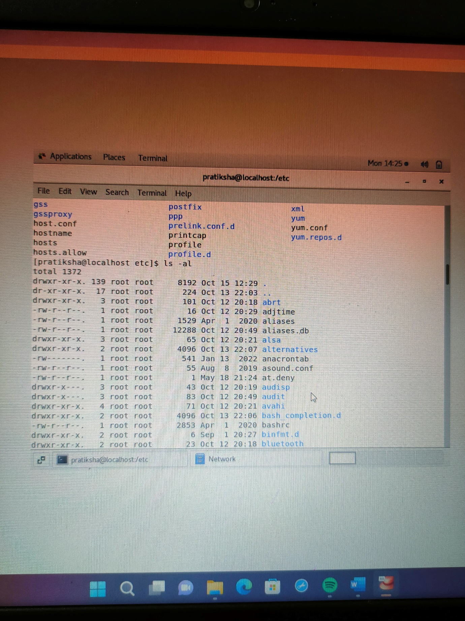Take screenshot and explain what new file or directory you found?
  + **Observation** : It will display list of permissions of files and the directories as well as other attributes such as folder names, file and directory sizes and modified date and time
* Then use **ls -i** and hit **Enter** key
  + 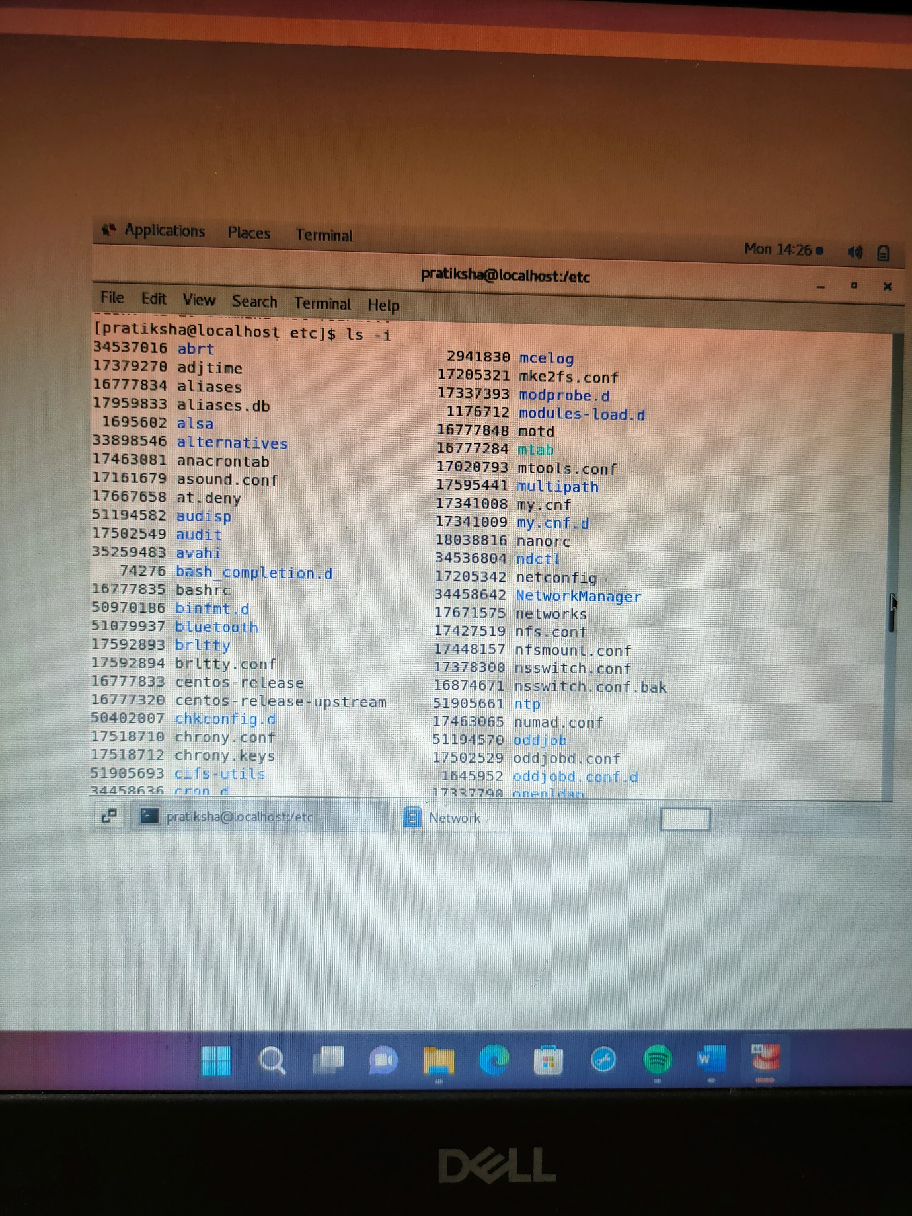Now see what different output its shows and take screenshot?

**Observation**: Displays inode number of files and directories

* Then use **ls –help** and see other options about **ls** command
  + Explore it and try with other attribute we can use with **ls** command

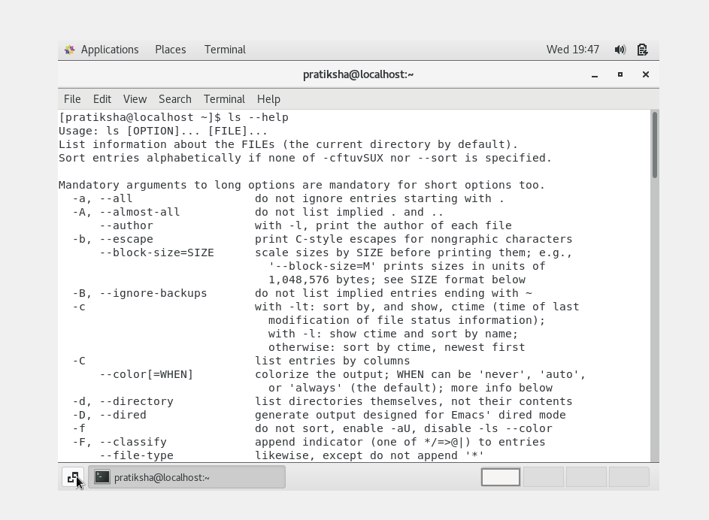

**Observation**: Lists all files and directories (files contained in current directory)

**Assignment-5**

Know where you are and where you working

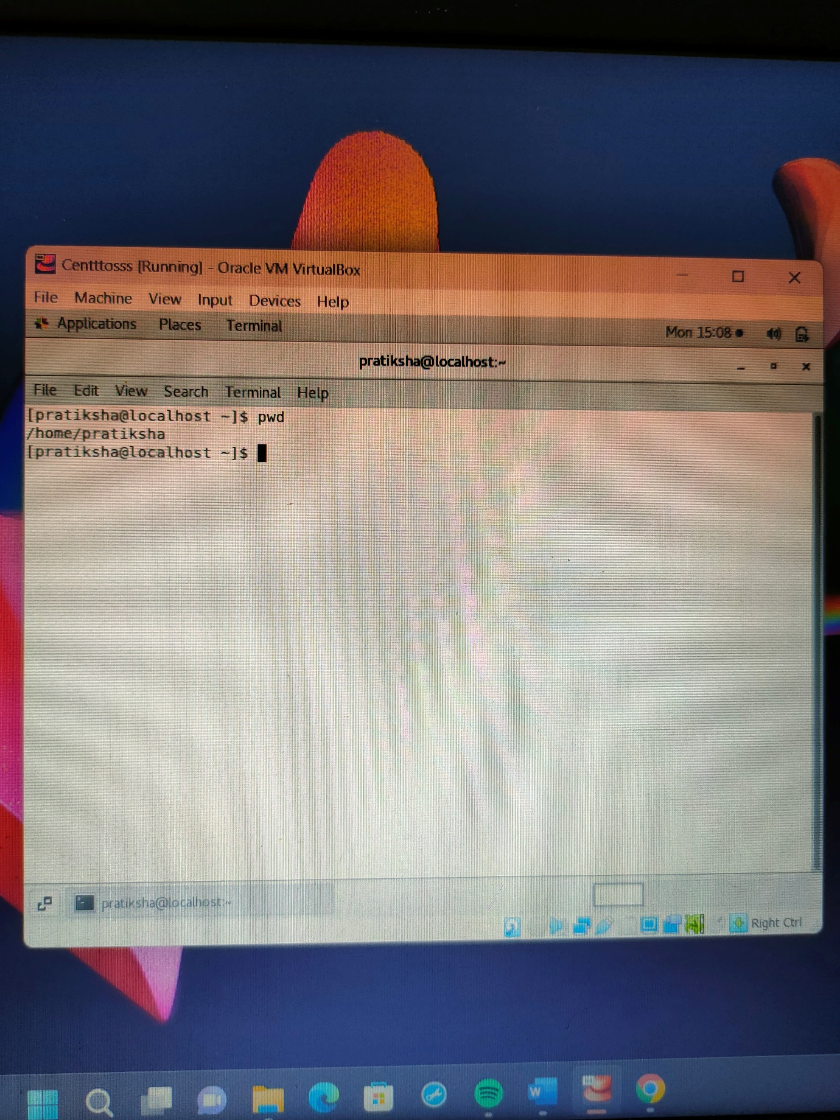*Here we use* ***pwd, cd and ls*** *as combine task to understand where you working on terminal and how you can switch from one directory to another one.*

* Open terminal after restart the linux
  + Check which location you working, type **pwd** and take screenshot

**Observation**: pwd writes standard output the full path name of current directory

* Now use **cd /var** and hit **Enter** key
  + Do **ls,** and see what output comes, give screenshot?
* Do explore other help options of each command to learn more other things we can do with these commands

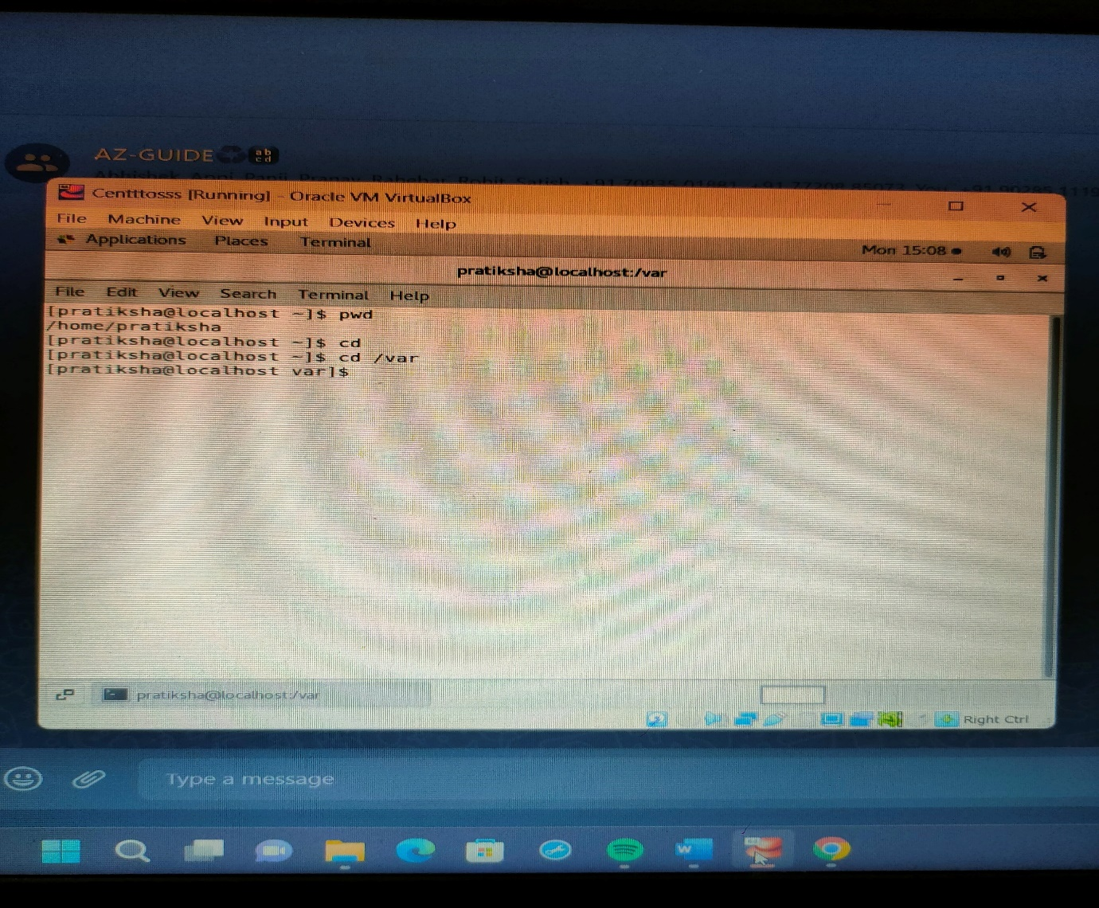

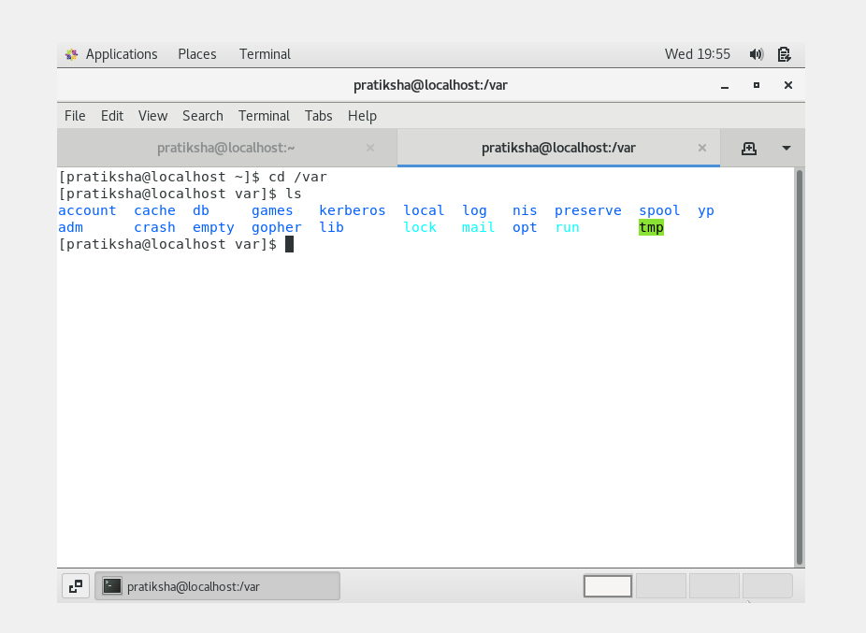

**Observation :** After adding cd /var and ls command it displays lists of files present in var directory.